

TREASURER’S GUIDE

This Quick Guide must be read in conjunction with RNA Bye Laws.

**What does the Treasurer do?**

**Role of a Treasurer**

Treasurers manage and keep track of all the financial data, which is why bookkeeping is so important. Without accurate records, how can you tell if your branch is making a Surplus or Deficit. Accurate and complete financial bookkeeping is crucial to any branch. Your job is critical to the smooth operation of the branch which helps the Committee to make key decisions. Treasurers must be vigilant about keeping paper records and reporting information about the financial transactions entered into the books.

To manage the day-to-day financial operations you will require either manual books or if you are computer literate enter the information onto spreadsheets, or, you can use a computer accounts package. These books should consist of the following:

* Day book for Memberships[1], Sales and Purchases
* Cash book for receipts and payments of cash / cheques / Bacs
* Petty cash book



**When is the financial year end?**

Your Branch Financial Year is 1 January – 31 December

(same as Central Office)

**What dates do I need in the Treasurer’s diary?**

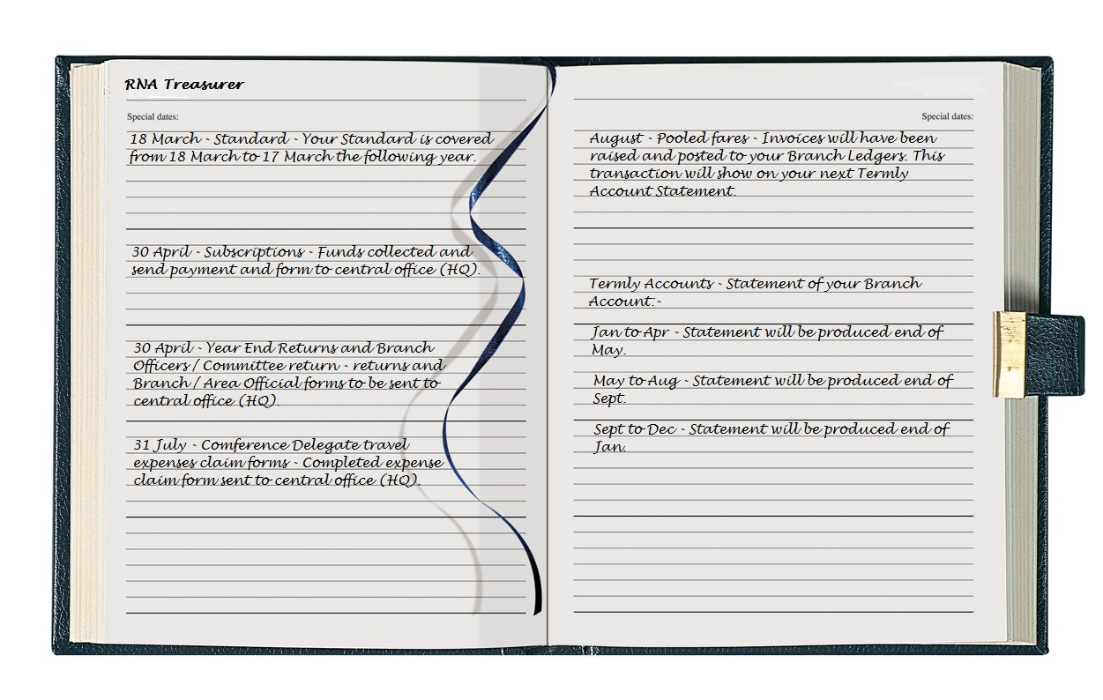

*Top Tip:*

*30 April Year End Returns should include Branch / Area Office Holders Information form.*

**MEMBERSHIP**

Usually the Branch Secretary will collect Shipmates Subscription payments, details of this transaction should be recorded on the relevant Membership form issued by Central Office (HQ), which you can find either on the RNA Website, December Circular or you can ring the Central Office (HQ) and request a copy, either by post or e-mail. Payment and a copy of this form should be sent to Central Office (HQ) by the 30 April.

The treasurer must record all payments and receipts in the Branch Day Book, including when existing members pay their subscriptions (as well as on the membership register.

(For full information on Membership please refer to the Branch Secretaries Guide).

For Life membership see the Branch Secretary’s Guide, the applications must be accompanied by a payment of 10 times the annual subscription.

**Membership Forms**

The RNA membership leaflet states the bank details to be used by those wishing to join as HQ Roll Members **only**. New members wishing to join a Branch should pay subscription using the Branch bank details or direct to Branch Official.

**YEAR END RETURN**

Branches and Areas must complete a Year End Return form (Branch RNA Form 2 & Area RNA Form 4) for the Financial Year 1 January – 31 December. These can be found at the [RNA Website](http://www.royal-naval-association.co.uk/members/downloads/admin/), December Circular or you can telephone the Central Office (HQ) and request a copy either by post or e-mail. All your figures from your Books and Bank Statements should be entered on the forms.

When completed and signed, one copy should be sent to Central Office (HQ) along with your Branch/Area Office Holders form (Branch RNA Form 1 & Area RNA Form 3) within 31 days of your AGM, but no later than 30 April (Branch Bye-Law B19 & Area Bye Law A17) and one copy to your Area Secretary.

It is vital that the Branch Returns represent a true and accurate statement regarding the financial status of a Branch. The Charity Commission has the right to inspect any and all accounts held at Central Office (HQ).

Club treasurers must complete separate returns based on the clubs audited accounts.

**CHARITIES COMMISSION**

**[2]**

If your Branch has income, from all sources of over £5,000 you must register with the Charities Commission and complete the annual criteria. This can be found on Charities Commission website. Branches in Northern Ireland, Republic of Ireland and Overseas should conform with the legislation in their jurisdiction. Branches in Scotland owning land or buildings report to OCSR.

You can always ask the Financial Manager if you are unsure what to do.

**How do I inform Central Office (HQ) of changes of Branch Officials?**

Branch/Areas that change Branch Officials need to forward a ‘Branch / Area

Office Holders Information form (RNA Form 1 or RNA Form 3)’ by post or e-mail to Central Office (HQ), to avoid Central Office contacting the wrong Shipmate.

You can obtain these forms from the RNA Website or you can ring for a copy.

**BANK MANDATE**

Branches/Areas must hold Bank and/or Investment, Post Office or Building Society Account in the name of the RNA…........Branch or RNA Area ……...

The Branch /Area Main Committee should nominate at least three members as authorised signatories for the Account. A minimum of two should be authorised to make payments or withdrawals. One of the nominees shall (Branch Bye-Law B20) be the Honorary Branch/Area Treasurer.

Bank signatories - please keep an eye on your Bank Mandate and ensure that signatories on Bank Accounts are updated when necessary. Please ensure the Bank is informed as soon as possible and a new mandate completed.

**Separate cheques, or just one?**

When sending payments for expenditure to Central Office (HQ), only one cheque is required but please itemise all the items on the back of the cheque, for example subscriptions, Christmas cards etc on the back of the cheque and don’t forget to keep a list for your own records on the back of the cheque stub.

**[](http://www.google.co.uk/url?sa=i&rct=j&q=&esrc=s&source=images&cd=&cad=rja&uact=8&ved=0ahUKEwjK5J7GoMHPAhXLAMAKHYCKBVAQjRwIBw&url=http://www.sqa.org.uk/e-learning/ECIntro02CD/page_14.htm&psig=AFQjCNEPoIv9vZV7wiK6-TaWxBxxJFc6zA&ust=1475674100640381)CONFERENCE**

No Branch is permitted to send a delegate to Conference unless it has observed the Regulations of the Association about the Year End Return, the payment of Subscriptions and long-term outstanding debts.

Delegates will not be allowed to register or vote if the Branch hasn’t met those requirements.

**POOLED FARES**

Please note the Pooled fare system is for Delegates Travel expenses only

Please note the RNA Central Office (HQ) will pay for Delegate’s Travel Expenses only. Any other costs incurred (i.e. Accommodation, food /drink) should be raised and negotiated with your Branch Officials. Expense Claim forms to be dispatched to Central Office (HQ) by 31 July.

Whether you send a Delegate or not, all Branches are required to pay a share towards the travel expenses of all Delegates attending. The amount is calculated by adding all the Delegates Expense Claim forms to form a total, then a formula is calculated by how many Branches are operational in the Association and how many members you have in your branch. Once the calculation figure is done, it is then checked and authorised by the National Chairman & the Association’s Accountant.

Central Office (HQ) will invoice Branches for pooled fares. Prompt payment is important. This fee goes back into the Branch & Club Support Fund.

The Treasurer must record this transaction in the Day Book.

**TERMLY ACCOUNTS**

**How can I reconcile my Branch accounts with accounts held by Central office (HQ) ?**

Termly accounts are sent out by Central Office (HQ) by email, however, those with no e-mail address, by post, showing the Branch statement, Invoices and Account Activity Summary, which shows any monies owed to Central Office (HQ).

On receipt, the Treasurer (in accordance with Bye Law B22a) must take necessary action and the balance is to be remitted to Central Office (HQ) with 28 days of the date of receipt of the account, otherwise a fixed penalty surcharge may be applied.

**STANDARD FUND**

Those that wish to cover their Branch Standard and have informed Central Office (HQ) will receive an invoice.

The Treasurer must record this transaction in your Day Book and the payment recorded in your Cash Book.

This is incredibly good value for money. A new Standard would cost over £700

**SLOPS**

Payment for slops must be made with the order.

**GIFT AID**

It is important that if a member pays income tax that you complete a gift aid part of the annual form, so that gift aid can be reclaimed by Central Office. There is a prize each year for the branch with the best percentage of Gift Aid forms.

**PUBLIC LIABILITY**

**Does your Branch hold Public Liability Insurance ?**

Should a Branch have their own Public Liability and the reason why ?

Public Liability Insurance will protect your Branch if members of the public suffer personal injury or property damage because of your activities (Branch Meetings, Collections, Parading of Standards & Fundraising Events).

The Central Office’s Public Liability insurance **DOES NOT** cover your Branch, therefore you are responsible for arranging your own Public Liability insurance.

Military Mutual Insurance Brokers have negotiated a bespoke insurance policy for the RNA Branch members at a very low, discounted rate. The policy has been tailored to meet the needs of the Branches and automatically includes:

* £5,000,000 Public Liability
* £10,000,000 Employers Liability
* £1,000 Money
* Member to Member Liability
* Excess £250.00 (Property Damage & Money)

This will cover Branches for their legal liability for injury to people by the Branch or people working for the Branch in a voluntary capacity.

To find out more or to obtain a quotation you will in the first instance need to go online:-

<https://www.themilitarymutual.com>

or type into a search engine “RNA Branch Insurance”.

Should you have any problems or do not have access to a computer, you can contact Florence at Military Mutual directly on 07880 359438.

**DONATIONS**

**How do I make a donation to the Central Charity Fund, Naval Service Memorial or General Fund?**

A letter with your cheque (or you can pay by BACs) stating where you would like the Branch donation to be placed, this will ensure the donation account is credited according to your request.

Cheque (made payable to ‘The Royal Naval Association’)

[](https://www.google.co.uk/imgres?imgurl=http://cliparts.co/cliparts/kcK/nBn/kcKnBn7ni.jpg&imgrefurl=http://cliparts.co/pictures-of-open-books&docid=Osj6M3nadLbMlM&tbnid=3Z2cH7AzdROFoM:&w=1598&h=988&bih=844&biw=1440&ved=0ahUKEwjBpvH7rsHPAhWJGT4KHa_GDgk4rAIQMwg9KDowOg&iact=mrc&uact=8)

BACs – Please ask Central Office for the Bank information

**CLOSING YOUR BOOKS MONTHLY**

Each month total up and close off entries

Closing your books and ensuring they balance means you get to show what your branch has done financially and can be reported to your Branch; then starting the cycle again for the next month.

If you take advantage of your bookkeeping information, and review that information throughout the year, the results give a good idea of how well your branch is doing. Also, your Year End Returns will indicate timely and accurate information.

**DECOMMISSIONING / DISBANDMENT OF THE BRANCH**

**What actions are required on Decommissioning a Branch?**

As per the Bye-Laws B29/B30

Once the decision has been made to close the Branch, the Treasurer / Secretary should write to the Central Office (HQ) explaining when your Branch is about to close. Any money remaining after your Branch has made the final disbursements should be sent to the Central Office (HQ). This money is placed in a 10 year account in case any Shipmate would like to restart a Branch in your area; the money will be available to the new Branch.

If you Branch has it’s own unique Charity Commission number, you will need to de-registered your Charity number from their register. Form can be found on the website [www.gov.uk/remove-charity-register](http://www.gov.uk/remove-charity-register)

**Where do I find Useful Forms for Branch accounts business?**

All forms can be found and downloaded from the [RNA Website](http://www.royal-naval-association.co.uk/members/downloads/admin/), Semaphore Circular or if you do not have access to the internet you can contact Central Office (HQ).

**What is the guidance on Branch Fund Investments?**

Under the FCA Regulations the Royal Naval Association Central Office (HQ) is not authorised to give advice on Investments. You can seek advice from a Professional Financial Advisor regarding investments that you may hold.



**Who can I ask for help?**

Bill Oliphant – General Secretary

Tel: 023 92 722983

E-mail: [bill@royalnavalassoc.com](mailto:bill@royalnavalassoc.com)

Michelle Bainbridge - Financial Manager

Tel023 9272 3823

E-mail:[michelle@royalnavalassoc.com](mailto:michelle@royalnavalassoc.com)

* Accounts (General)
* Charity Commission
* Suspension of Branches
* Standard Cover
* Bank Mandates
* Travel Claim Forms
* Public Liability
* Area Capitation
* Conference queries
* Pooled Fares
* Donations
* Decommissioning Branches

Kathryn Brindley - Finance Assistance

Tel: 023 92 723823

E-mail: [kathryn@royalnavalassoc.com](mailto:kathryn@royalnavalassoc.com)

* Branch / Area Year End Returns
* Branch Office information form
* Termly Accounts
* Branch queries

Nigel Huxtable – Membership Support Manager

Tel: 023 9272 3747

E-mail: [nigel@royalnavalassoc.com](mailto:nigel@royalnavalassoc.com)

* Membership
* Life Membership
* Slops
* Gift Aid
* Conference Delegates

1. The Day Book should provide for the member to spread payment of subscriptions and other monies over the year
2. England, Wales and in Scotland for those branches not owning property.